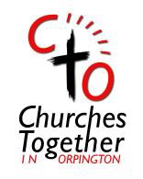 *(Please send any prayer intentions for December before the end of November)*

**1st November:**  We pray for The Elderberry Cafe which is held every Wednesday morning at St Paul’s. We pray for all those who come along from the community that they will meet with a warm welcome and experience the blessing of God’s Holy Spirit as they enjoy a coffee and a chat. We pray too for volunteers to come forward so that the cafe can open for longer hours during the winter months**.** Amen.

**2nd November:** We pray for all the churches that are to provide set times for Warm Space projects, for those who find difficulty in heating their homes. May it prove a time many will learn of the love of the Lord, through the care shown them. Amen.   
(See more at end of prayer list)

**3rd November:** We pray for the Alpha Courses and Discipleship programmes taking place, that many will come to know the love of the Lord and become missionary disciples reaching others people with the Good News of Christ, so the Holy Spirit may touch all hearts bringing them to faith. Amen.

**4th November:** Bromley Homeless – We pray for the work of Christians working together in partnership. We pray for the houses - one for homeless people looking for more stable accommodation and one for refugees, that these facilities will be blessed and those too that use them. Amen.   
  
**5th November:** We pray for our Bromley Borough Council and MP Gareth Bacon, that the Lord will support them in their decisions, so they will work for the common good. Amen.

**6th November:** We pray for our Town Centre and Orpington 1st management, that decisions be made that will benefit the town and those that live, work or visit here. Amen.

**7th November:** We pray in thanks for those clients who have become debt free, and pray for Christians Against Poverty (CAP) ongoing debt clients, for those attending all sessions and that more people will attend the Job club course; that volunteers will come forward to help, train and lead/coach sessions. We pray the courses are part of a journey to become involved in church communities and sense the love of Jesus by his Holy Spirit. Many clients suffer from mental health issues and the isolation caused. We pray for their welfare and all the needs of CAP. Amen. (See more CAP requirements at the end of the prayer list.)

**8th November:** Street Pastors: Orpington Street Pastors We give thanks for 16 years of patrols on Orpington High Street. We give thanks for Jeanette, from St Paul's Crofton who is currently training to join us. We give thanks for Taiwo, from Christ Apostolic Church, who has transferred to us from Bexley. We pray for our planning to do Saturday daytime patrols through Advent, that there will be enough of the team available to make it happen. We continue to pray for those we meet and chat to, that our conversation might plant seeds of faith. We continue to pray for the Lord to touch the hearts of more people to train and join our team. Amen  
  
**9th November:** We pray that the Lord will renew our hope & give us the faith to reach out to the communities in which we have been placed. We ask that you will equip & send your people. We believe that your desire is to renew the Church, so we pray, come Holy Spirit. Amen  
 **10th November:** We pray for Chelsfield and Green Street Green and Pratts Bottom parish for the launch of their Messy Church on Saturday 19th November. We pray for Kim Curle who will be leading it and all the volunteers and those who attend that it will be a channel for God's Spirit to guide and lead those who come. Amen.

**11th November:** We pray for Café Joseph at Holy Innocents’, & the Wednesday Luncheon club for all; that volunteers needed will be forthcoming & the word will spread that all will be welcomed as customers & enjoy the fellowship. Amen.

**12th November:** Outreach in Orpington – We pray for the outreach which continues every week on Wednesdays between 11.30 – 1pm. May many learn of the love of God & turn to Christ. Amen. *(Julian invites anyone who is interested in this ministry to please come and see him. Volunteers are accompanied.)*

**13th November:** We pray for the Anxiety & Stress sessions to be held at Orpington Baptist church, may many attend and all benefit from their attendance. Amen.

**14th November:** We pray for those being persecuted for their faith. May the Lord console & comfort all those hurting. We choose Christ & stand up for Faith & Freedom and will support Christ in his suffering Church as he supports us. Amen.

**11th November:** We pray for the victims of Trafficking & those who work to combat it; we ask for liberation, healing, restoration, purpose, justice & salvation for the victims. We pray too for opened eyes, repentance, & salvation for traffickers. Amen.

**12th November:** We pray for the Bromley Brough foodbank, that enough food and monetary donations will be forthcoming for it to continue providing service to people in need., Also for Unity Church, its community fridge & Garden; for St Nicholas’ Community Larder & the Open kitchen at Christchurch; the Food Hub at Hope Church, praying that many in the community will get involved so that all can deepen friendships. We pray for wisdom as they develop all projects. Amen.

**13th November:** We pray for the work of Transform Bromley Borough (TBB), for the good done in the name of the Lord. May it continue to aid those in the borough. May the online prayer meetings draw more to praise and petition the Lord. Amen.

**14th November:** We pray you will enable your people to bring comfort, hope and your word of life to the weary, the confused and those living in darkness. Lord, we trust in your unfailing love, and our hearts rejoice in your salvation. We pray that others will see Jesus and be drawn to the Saviour of the world. Amen  
 **15th November:**  We pray for all our Ministers, Priests and Church leaders, that the fellowship they share will deepen and that unified in the love of the Lord, they be a testament to our town of Christ’s love. Amen.

**16th November:** We pray for our Vision – Working together in mission to reach out to our community in Orpington for God. May there be many opportunities to witness to our town to advance the Gospel and for God’s Kingdom to grow. Amen.

**17th November:** We pray for young people, that they remain true to Christ, that they build a strong relationship with the Lord and resist any temptations from their peers and the secular world. Amen.

**18th November:** We pray for all those in all the countries of the world where the covid infection continues being virulent and deadly. May all carers be kept safe and be given the strength to cope with the stress and risks they face in caring for the sick. We pray too that the Lord will take this covid and Monkey pox infection away from the world. Amen.

**19th November:** We pray for our Government and World leaders, in making decisions that will benefit us all, including wildlife and nature, that more trees will be planted and there be minimal polluting of rivers and streams; and for the efforts that each of us is making to eliminate or reduce anything that has an adverse effect on world climates. Amen

**20th November:** We pray for those with low incomes who are concerned with rising costs in energy and other bills and any reductions in benefits. May provision be made to assist them. Amen

**21st November:** We pray forthose undergoing medical tests who are anxious and fearful of the potential diagnosis. Should their condition prove to be serious may the Lord heal, support and console them and their families at this fraught time. Amen.   
 **22nd November:** We pray for all the groups run by our churches, for children, young and the elderly or for any community needing support. May the love of Christ be felt by all who attend. Amen.

**23rd November:** We pray forthe safety of unborn babies, that their mothers will be supported throughout the pregnancy, and the birth be without problems. Amen.

**24th November**: We pray for volunteers on probation, those in service and those who have completed their time and are resuming daily activities. We pray for those employed and those unemployed, that they will have the incentive to seek and find employment. We prayer for all volunteers that God will provide and sustain them. Amen.

**25th November:** We pray ...Loving God, You are always near to us, especially when we are weak, suffering and vulnerable. Reach out to those who experience mental illness, for those suffering chronic pain or are unwell in any way. Lift burdens, calm anxiety, and quiet fears. Surround all with your healing presence that they may know they are not alone. Amen.   
 **26th November:** We pray for Ukraine and all war-torn Countries, that mercy and justice be found for all and those who wage war against nations cease to do so, and instead, find ways to bring justice and peace instead of raining down death and destruction on others. Amen.

**27th November:** We pray for the sick & those who care for them and for those whose surgery has been delayed by the consequences of the pandemic, that they have resolution of their problems, be supported in their wait and come to no lasting harm from the delay. Amen

**28th November:** We pray for prisoners and their families, that they realise the Lord loves them unconditionally, that they feel his presence with them always. May all prisoners receive the support and understanding from the community that will enable them to rehabilitate into society and their families be helped to cope. Amen.

**29th November:** We pray for all the businesses, employees and self-employed whose livelihoods and jobs have been threatened or have been lost. May all people work together for the good of the country and recovery of the economy. May the Lord take the anxieties and concerns from all and grant His peace and strength to those suffering in any way. Amen

**30th November**: We pray the Lord, comfort & console those that are grieving thus suffering the pain of loss, giving them peace and consolation that only Christ can give. Amen.

We pray for justice & peace, especially racial justice, also for migrants & refugees that they be welcomed into society; that there be an end to division, strife & war & that all people will be appreciated, cared for, & work together for the good of all. Amen.

We pray that the Lord will touch the hearts of terrorists so that they may recognize the evil of their actions and that they may turn to the way of peace and goodness, of respect for the life and for the dignity of every human being, regardless of religion, origin, wealth or poverty. Amen.

************************

**(NB: Re Christians Against Poverty.** **(CAP) Prayer always needed.**  
Much of CAP work is in Orpington and the Crays BR5 and BR6. There is a Job club in Central Bromley and one also running from The Unity church Orpington) Volunteers from churches in Orpington support this as volunteers Praise be to God. There will be another Cap Life skills course running from The Unity Church on the Ramsden Estate in the new year.

Regular monthly funding needed as we seek to develop this work across the Borough.

If You wish for the debt centre manager or others to come and share about our work do contact [martinpointing@capuk.org](mailto:martinpointing@capuk.org))

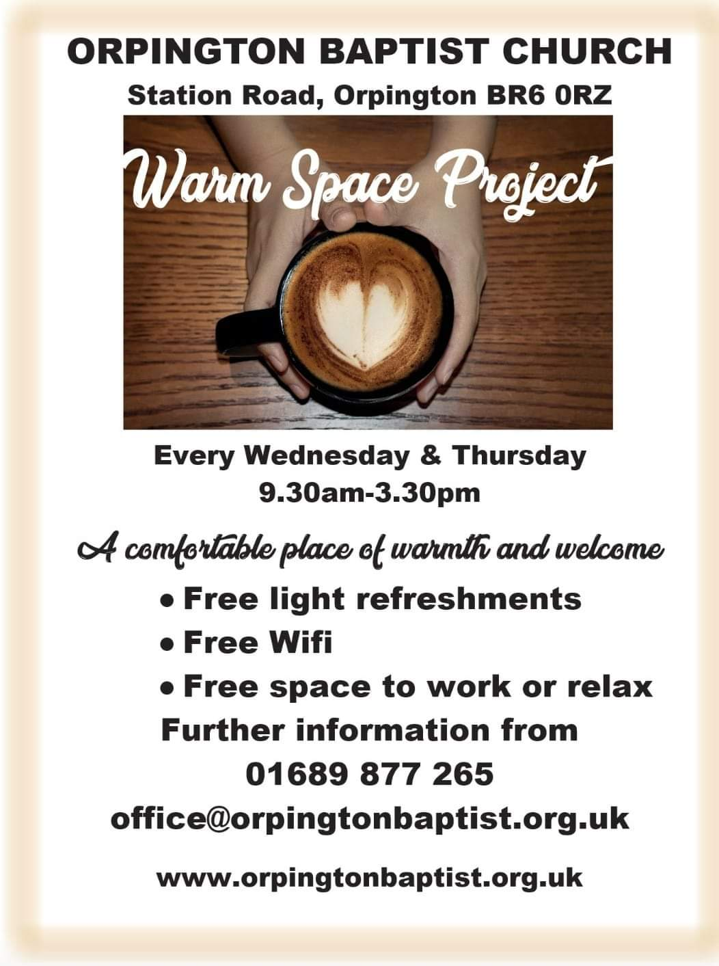 **Green St Green Baptist Church   
Mondays 10am-2pm**

You can register your space on the national website:

[https://warmspaces.org/#map](https://warmspaces.org/" \l "map)

**Hope Church** is also planning to provide a warm space

There may be others too.